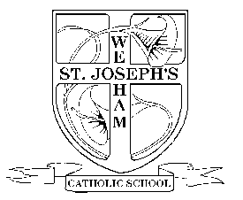

St. Joseph’s Catholic Primary School

School Eco Group Application Form

What makes you the best person for the job? e.g. caring, imaginative, friendly, able to work in a team

The Eco School group are always thinking of ways to improve our school. What ideas do you have to make our school more Eco Friendly?

Surname

Class

First Name

Why do you want to be a member of the Eco School group?

Please complete the questions below to apply for a position as a member of our Eco School Group. You can either hand write your answers on this sheet and hand it into Mrs Gilfoyle or send it electronically by typing on the form. It can be downloaded from the school website [www.st-josephs-kirkham.lancs.sch.uk](http://www.st-josephs-kirkham.lancs.sch.uk) and sent back to [ann.gilfoyle@st-josephs-kirkham.lancs.sch.uk](mailto:ann.gilfoyle@st-josephs-kirkham.lancs.sch.uk). The closing date is Tuesday 1st December ’20. Good Luck!